

Travel Away
Infosys Ltd
Artifacts | Value
Version No. | 1.0
Authorized by | ETA Unit Head

© 2017 Infosys Limited. Strictly private and confidential. No part of this document should be reproduced or distributed without the prior permission of Infosys Limited.

Confidential Information
This proposal is confidential to Infosys Limited ("Infosys"). This document contains information and data that Infosys considers confidential and proprietary (“Confidential Information”).
Confidential Information includes, but is not limited to, the following:
- Corporate, employee and infrastructure information about Infosys
- Infosys’ project management and quality processes
- Customer and project experiences provided to illustrate Infosys capability
Any disclosure of Confidential Information to, or use of it by a third party, will be damaging to Infosys. Ownership of all Confidential Information, no matter in what media it resides, remains with Infosys.
Confidential Information in this document shall not be disclosed and shall not be duplicated, used, or disclosed – in whole or in part – for any purpose other than to evaluate this proposal without specific written permission of an authorized representative of Infosys.

Table of Contents
1. TravelAway Background 1
2. TravelAway Requirements 1
3. TravelAway Requirements – User 1
3.2 Customer Registration 1
3.2.1 Validation/Acceptance criteria 1
3.2.2 Sample screen 1
3.3 Customer Login 1
3.3.1 Validation/Acceptance criteria 1
3.3.2 Sample Screen 1
3.4 Edit Customer Profile 1
3.4.1 Validation/Acceptance criteria 1
3.4.2 Sample screen 1
3.5 Customer Logout 1
3.5.1 Validation/Acceptance Criteria 1
3.6 View All Packages 1
3.6.1 Validation/Acceptance Criteria 1
3.6.2 Sample Screen 1
3.7 View Package Details 1
3.7.1 Validation/Acceptance Criteria 1
3.7.2 Sample Screen 1
3.8 Book Package 1
3.8.1 Validation/Acceptance Criteria 1
3.8.2 Sample Screen 1
3.9 Select Accommodation 1
3.9.1 Validation/Acceptance Criteria 1
3.9.2 Sample Screen 1
3.10 Payment 1
3.10.1 Validation/Acceptance Criteria 1
3.10.2 Sample Screen 1
3.11 Rent Vehicle 1
3.11.1 Validation/Acceptance Criteria 1
3.11.2 Sample Screen 1
3.12 Rating 1
3.12.1 Validation/Acceptance Criteria 1
3.12.2 Sample Screen 1
3.13 Customer Care 1
3.13.1 Validation/Acceptance Criteria 1
3.13.2 Sample Screen 1
4. TravelAway Requirement – Employee 1
4.1 Employee Login 1
4.1.1 Validation/Acceptance criteria 1
4.1.2 Sample Screen 1
4.2 Generate Report 1
4.2.1 Validations/Acceptance Criteria 1
4.2.2 Sample Screen 1
4.3 Start/End Ride 1
4.3.1 Validations/Acceptance Criteria 1
4.3.2 Sample Screen 1
4.4 Add New Hotel 1
4.4.1 Validations/Acceptance Criteria 1
4.4.2 Sample Screen 1
4.5 Add New Vehicle 1
4.5.1 Validations/Acceptance Criteria 1
4.5.2 Sample Screen 1

TravelAway Background
TravelAway is an innovative travel and tourism company. TravelAway provides the following services:
- Planning tours and holiday packages
- Booking tours and holiday packages
- Arranging transportation and accommodation
- Customer Care
TravelAway runs its business with an enormous amount of manual effort in planning, booking and capturing data for travel and tourism. You are expected to build the following applications for TravelAway.
- A B2C (Business to Customer) application where the end user can use the application to book packages
- A B2B (Business to Business) application where the employees of TravelAway use the application to plan the packages
The above applications are expected to be built using the following technology stack:
Layers | Technology
Presentation | Angular (B2C and B2B)
Business | C#
Service | ASP.NET Web API Core
Data Access | ADO.NET/ Entity Framework Core
Database | MS SQL Server

All the screen captures/images are for representation only. You are free to design the web page. Ensure UX practices are followed.

TravelAway Requirements
The following functionalities need to be implemented as part of developing the B2C application using the mentioned technology stack.
- New Customer Registration
- Customer Login
- Edit Customer Profile
- View all Packages
- View package details
- Book Packages
- Select Accommodation
- Rent Vehicle
- Payment
- Customer Rating
- Customer Care
The following functionalities need to be implemented as part of developing the B2B application using the mentioned technology stack.
- Employee Login
- Generate Report based on
  - Packages Booked
  - Booking Per Month
  - Revenue Generated
- Start/End Rented Vehicle Ride
- Add new packages, visiting places, hotels and vehicles

TravelAway Requirements – User
The following functionalities need to be implemented as part of developing the TraveAway using the above-mentioned technology stack.

Customer Registration
As a Customer, I should be able to create an account so that I can use the services of the Travel Company.

Validation/Acceptance criteria
- First Name should allow only alphabetical letters with no spaces
- Last Name should allow only alphabetical letters with no spaces
- EmailId should follow a valid format
- Password should be between 8-16 characters
- Confirm password should be same as password
- Gender should be Male or Female
- Contact Number should be number; 1st digit cannot be zero and the length should be 10 digits
- Date of Birth should be a valid date and should be less than the current date
- Address can contain alpha numeric values with special characters (if any)
- All fields are mandatory
- On successful validation, customer should be registered
- In case of any error or exception, appropriate error messages should be displayed

Sample screen

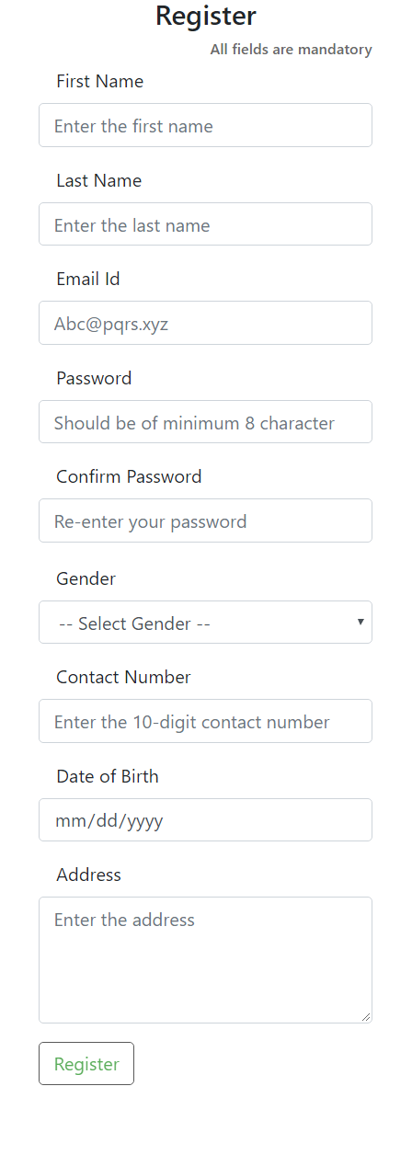
Figure-1 Customer registration page

Customer Login
As a Customer, I should be able to login using my credentials so that I can search for packages, view package details and book packages.

Validation/Acceptance criteria
- EmailId should follow a valid format
- Password should be between 8-16 characters
- On successful validation, the customer should be redirected to the home page (links for Searching for packages, Viewing Packages, Edit Profile, View Bookings, etc.)
- In case of any error or exception, appropriate error messages should be displayed

Sample Screen

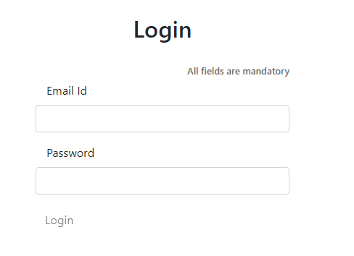
Figure-2.1 Login Page

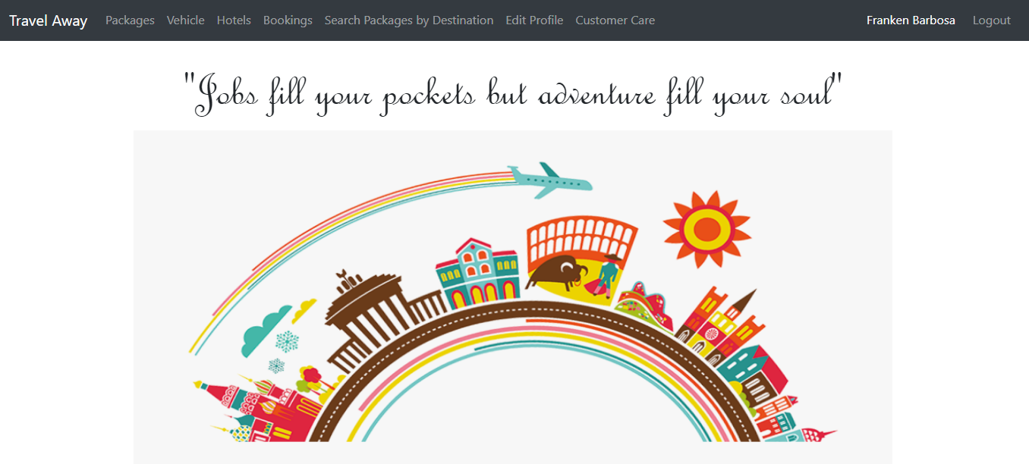
Figure-2.2 Customer Home Page

Figure-2.3 Links on Customer Page

Edit Customer Profile
As a customer, I should be able to edit my profile, so that my new contact details can be used for package booking.

Validation/Acceptance criteria
- Customer can change their First Name, Last Name, Contact Number, Gender, Date of Birth and Address
- First Name should allow only alphabets and no spaces
- Last Name should allow only alphabets and no spaces
- Gender should be either Male or Female
- Contact Number should be a number; 1st digit cannot be zero and length should be 10 digits
- Date of Birth should be a valid date and should be less than the current date
- Address can contain alpha numeric values with special characters (if any)
- If above validations succeed, then the data should get updated in the database
- For any exception, appropriate error message should be displayed

Sample screen

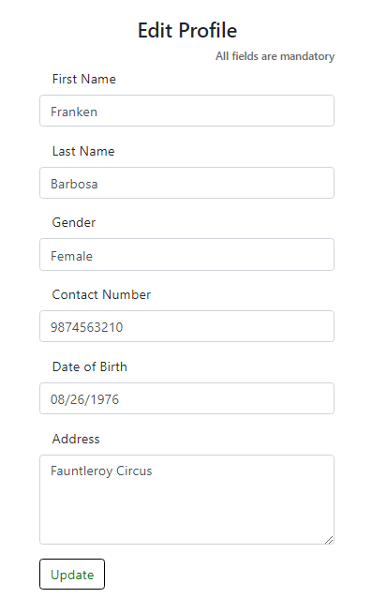
Figure-3 Edit Profile page after customer login

Customer Logout
As a logged in Customer, I should be able to logout from the website.

Validation/Acceptance Criteria
- After logout, the customer should be redirected to login page
- Click on the back button in the browser, the customer should be redirected to the login page

View All Packages
As a customer, I should be able to view all the packages available for both domestic and international destinations, so that I can select a package for booking.

Validation/Acceptance Criteria
- Customers should be displayed with all the available packages along with package category
- Sample package categories can be
  - Adventure
  - Nature
  - Religious
  - Village
  - Wildlife
- Package information should display all the images of the destinations, package names and their descriptions

Sample Screen

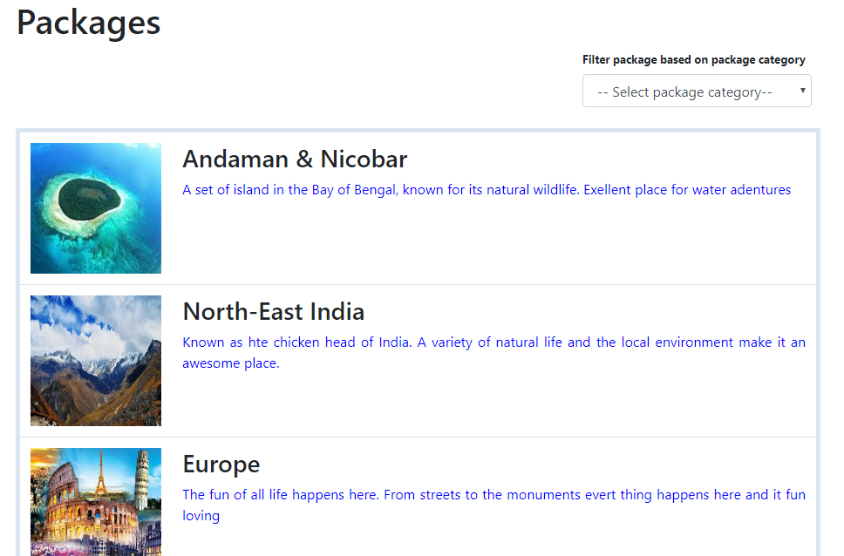
Figure-4.1 Available packages

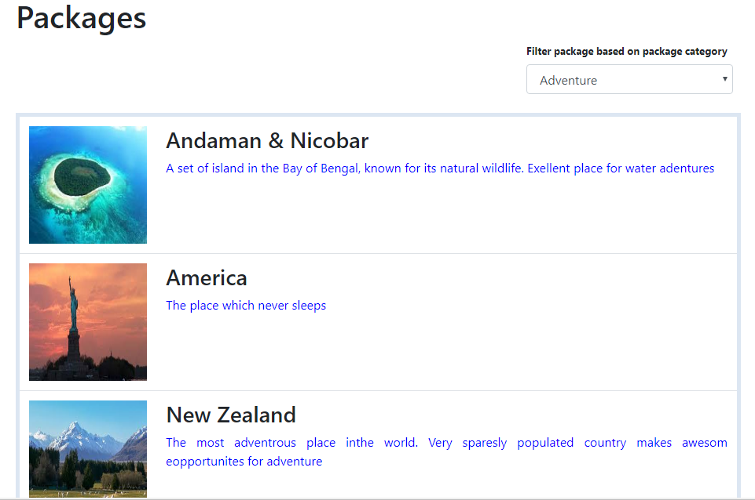
Figure-4.2 Filtering packages based on choice of package category.

View Package Details
As a customer, I should be able to view all the sub-package details available for a selected domestic or international destination package, so that I can book a package.

Validation/Acceptance Criteria
- Customers should be able to click either on the image or the package name
- Customer should be navigated to a details page
- Customer should be displayed with all the following sub-package details along with the package name and the package category:
  - Places to visit
  - Description
  - Details like Number of days/nights
  - Price per adult
  - A button to Book the package

Sample Screen

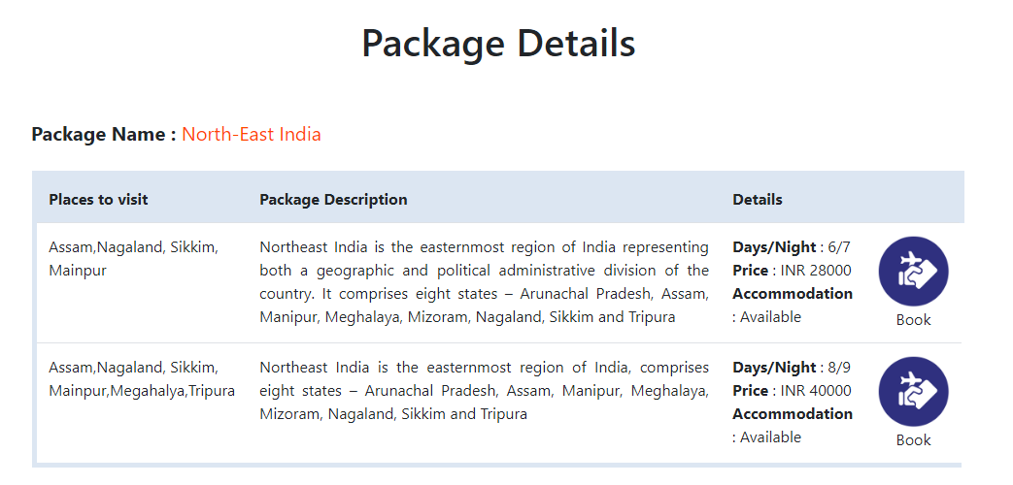
Figure - 5 Package Details after clicking on package

Book Package
As a customer, I should be able to book a package, so that I can select accommodation and make payment for TravelAway.

Validation/Acceptance Criteria
- Customer should be able to click on the Book Package button in the Package Details page
- Customer should be navigated to a page to enter the following details:
  - 10-digit Contact Number
  - Residential Address
  - Date of travel
  - Number of Adults travelling. Minimum should be one
  - Number of children travelling. Minimum can be zero
- On all successful validations, add the booking details in the database with the status as 'Booked', along with the EmailId of the logged in user
- Navigate the customer to Select accommodation.
Provide an option to the customer asking, whether he wishes to proceed to book accommodation or not.
- In case the customer wishes to proceed, navigate to select accommodation.
- In case the customer rejects, navigate to booking history page.

- On any exception, display appropriate error

Sample Screen

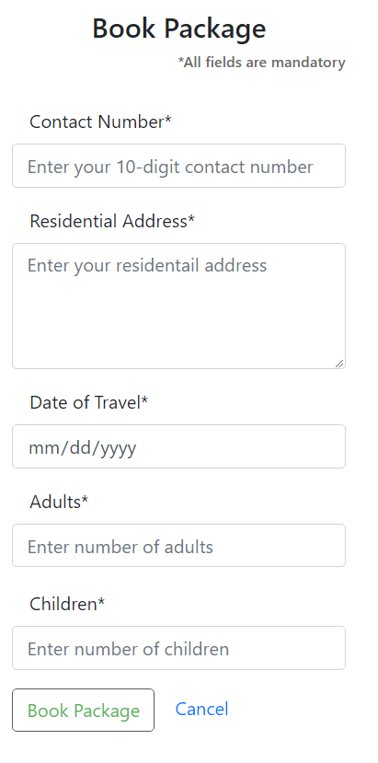
Figure - 6.1 Booking details page.

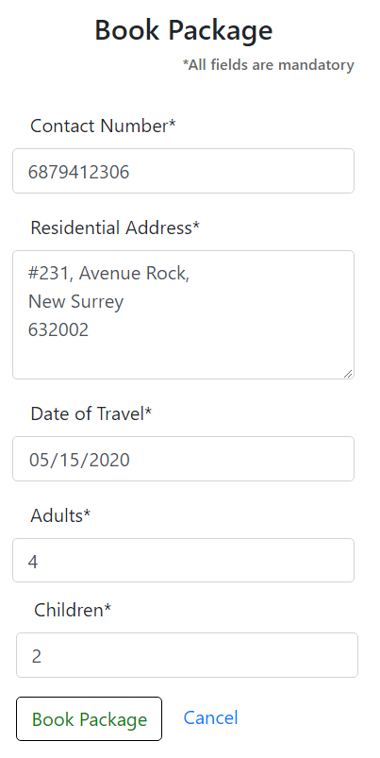
Figure -6.2 Booking details page with values

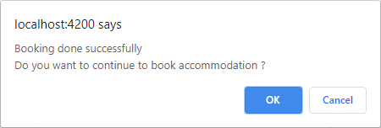
Figure - 6.3 Confirmation to proceed to accommodation page

Select Accommodation
As a customer, I should able to select accommodation for my package, so that I can make payment and confirm for TravelAway.

Validation/Acceptance Criteria
- Customer should be displayed with the BookingId and should be disabled
- Customer should be able to
  - select the city of visit
  - select the hotel type - 2-star, 3-star, 4-star and 5-star
  - select hotels based on the city and hotel type selected
  - enter number of rooms for booking
  - room type can
    - Single
    - Double
    - Deluxe
    - Suite
- Cost should be calculated and displayed based on the hotel room cost and the number of rooms
- Add the accommodation details for the BookingId in the database
- On successful addition of details, navigate the user to Payment page
Provide an option to the customer asking, whether he wishes to proceed for payment or not.
- In case the customer wishes to proceed, navigate to payment page.
- In case the customer rejects, navigate to booking history page.

Sample Screen

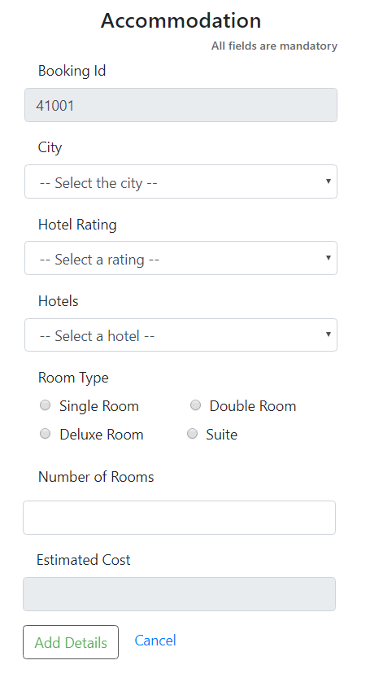
Figure - 7.1 Accommodation page without details

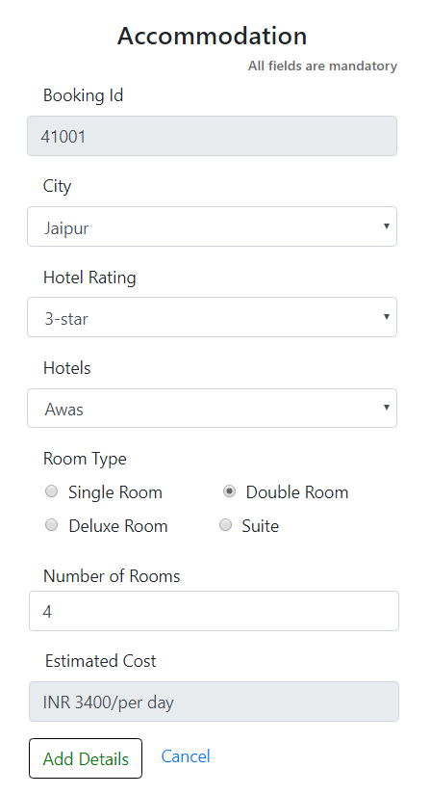
Figure - 7.2 Accommodation page with details

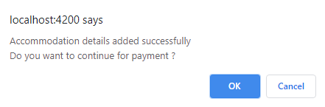
Figure - 7.3 Confirmation to proceed to payment page

Payment
As a customer, I should be able to make payment for my package bookings, so that booking status is confirmed.

Validation/Acceptance Criteria
- Customer should be navigated to a payment page to enter the following details:
  - Booking Id
  - Total amount to be paid should be auto populated and made as read-only
    - Calculate total amount based on package price per adult, number of adults and number of children
    - Amount price per child can be half the package price per adult
    - Include the accommodation cost
- Update the booking status as ‘Confirmed’ on successful payment for the given BookingId
- Display appropriate error messages for an error

Sample Screen

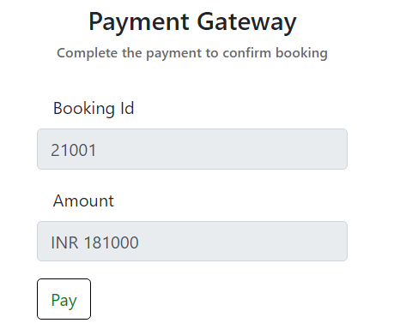
Figure – 8 Payment Gateway

Rent Vehicle
As a customer, I should be able to rent a vehicle, so that I can go for sight-seeing once I reach the destination city.

Validation/Acceptance Criteria
- Date of renting should be current date or greater than the current date
- Customer should be able to select a type of vehicle. The vehicle type can be:
  - Two-Wheeler – Cycle or Bike or a scooter
  - Mini-Bus
  - Four-Wheeler
- Vehicle pick-up time slot should be between 5 AM to 6 PM
- Minimum number of hours to rent should be 3 hours
- The amount should be calculated based on the number of hours or number of kilo meter of the ride. An additional base charge would be included in the amount
Amount = (Number of hours * Number of kilometers) + Base charge
Vehicle Type | Base Charge
Two-Wheeler | 100
Four-Wheeler | 200
Mini-Bus | 350

Sample Screen

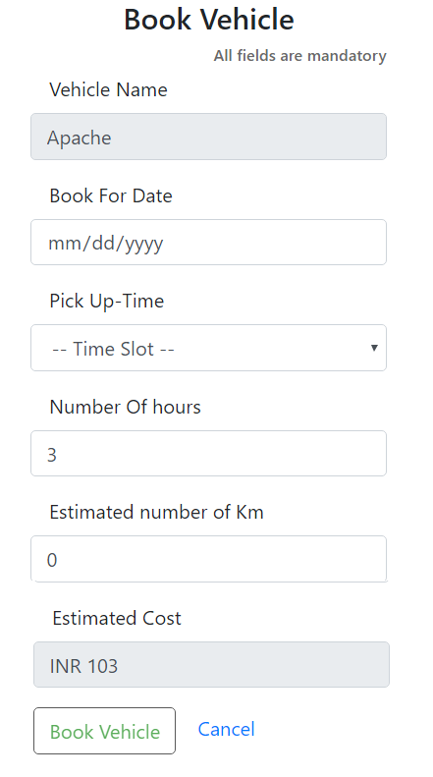
Figure – 9.1 Rent Vehicle page without details

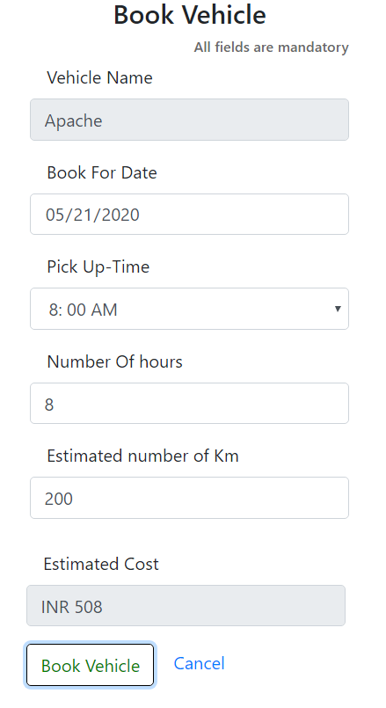
Figure – 9.2 Rent Vehicle page with details

Rating
As a customer, I should be able to provide star rating, so that I can share my experience on the package I booked with TravelAway.

Validation/Acceptance Criteria
- Customer should be allowed to provide rating and comments based on the BookingId
  - The ratings should be between 1 and 5
  - Comments should be provided in words based on the customers experience
- On successful validation, customer should be redirected to the home page
- In case of any error or exception, appropriate error messages should be displayed

Sample Screen

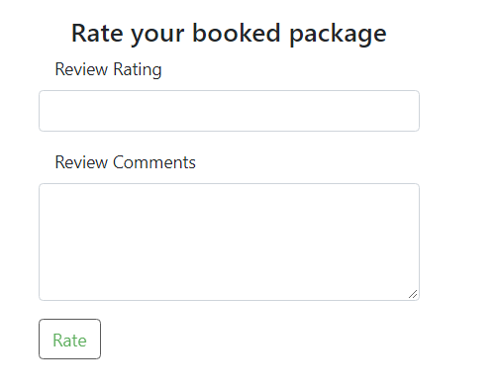
Figure – 10.1 Rating page without details

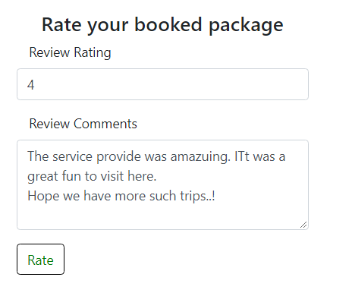
Figure – 10.2 Rating page with details

Customer Care
As a customer, I should be able to contact a customer care agent to answer queries, so that my queries will be answered before I book or travel.

Validation/Acceptance Criteria
- Customer should be able to raise a request along with the query to be answered for a BookingId
- The query should be registered in the database with 'assigned' as the status and assigned with an assignee
- Customer should receive an answer for the query and the status should be changed to 'In progress' in the database
- Every question should be registered in the database along with the answer by the assignee
- The request should be closed based on the confirmation by the customer and the status should be updated as 'closed' in the database

Sample Screen

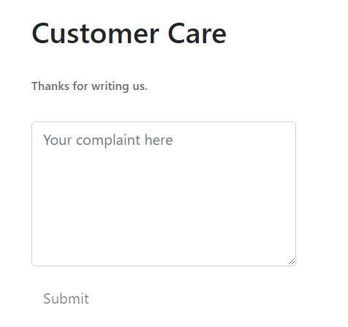
Figure – 11.1 Customer Care page without details

TravelAway Requirement – Employee
The following functionalities need to be implemented as part of developing the TravelAway website using the above-mentioned technology stack

Employee Login
As an employee, I should be able to login using my credentials, so that I can perform administration operations for the travel company

Validation/Acceptance criteria
- Validating the input details based on the following conditions:
- EmailId should follow a valid format.
- Password should be between 8-16 characters
- On successful validation, customer should be redirected to the home page (links for Add New Package Details, Add Hotel, Add Vehicle, Generate Reports)
- In case of any error or exception, appropriate error messages should be displayed

Sample Screen


Figure – 12.1 Login Page

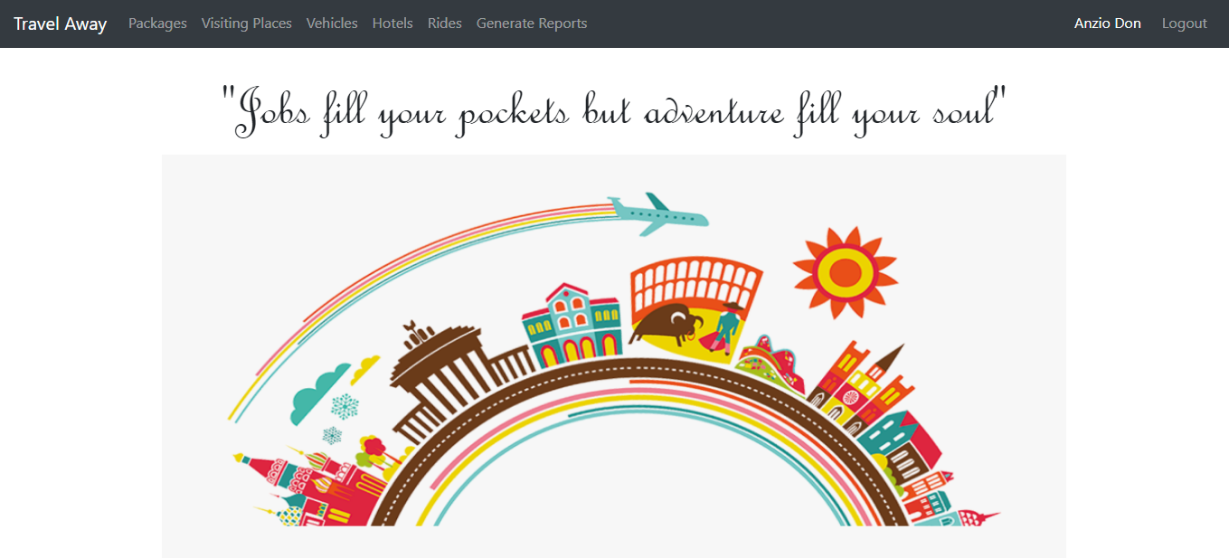
Figure – 12.2 Employee Home Page

Figure – 12.3 Links on Employee Home Page

Generate Report
As an employee, I should be able to generate a report based on various parameters, so that the travel company can perform analysis.

Validations/Acceptance Criteria
- Reports should be generated based on the following parameters:
  - Number of packages available under a given PackageCategoryId
  - Bookings for a given month (display PackageDetailsId, Number of Bookings for each PackageDetailsId)
  - Revenue generated between given months (display month and year along with the total amount for each month)
- In case of any error or exception, appropriate error message should be displayed

Sample Screen

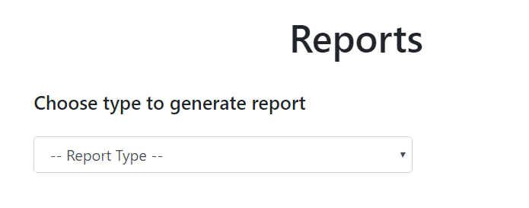
Figure – 13.1 Report page without report

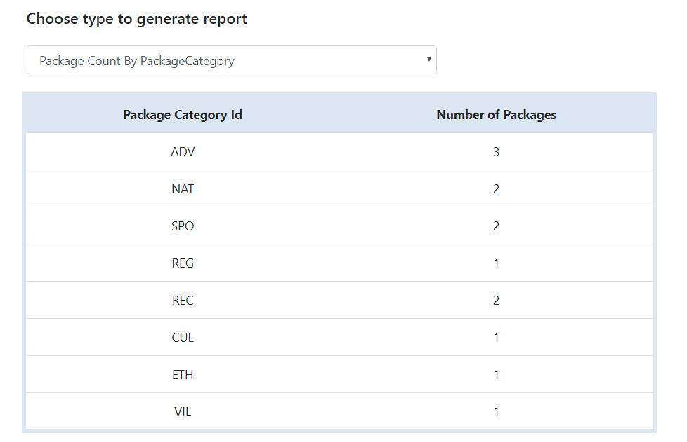
Figure – 13.2 Report generated for number of packages under a package category

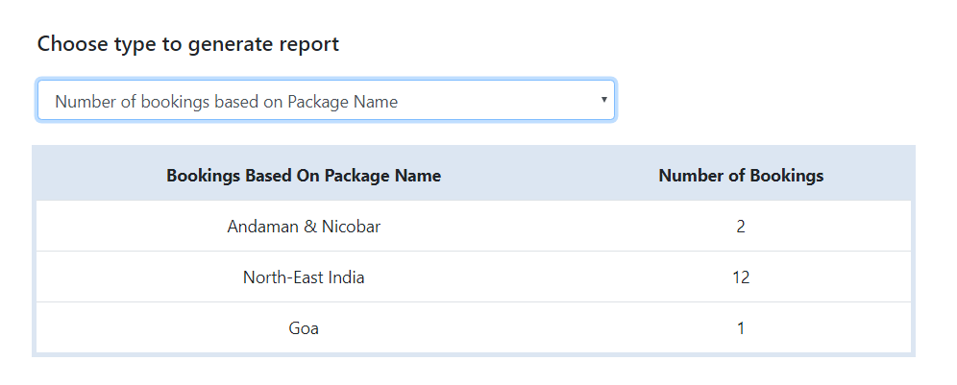
Figure – 13.3 Report generated for number of booking in each package

Start/End Ride
As an employee, I should be able to start ride or end ride, so that the charges for the vehicle rented by a customer can be calculated.

Validations/Acceptance Criteria
The employee should be able to select the rented vehicle details based on the BookingId.
- On click of the start button, the ride should start, and the status should change to 'Active' in the database
- On click of end button, the ride should end, and the status should change to 'Closed' in the database
- Based on the duration, rate per hour/rate per KM, the total amount to be paid should be calculated, displayed and updated in the database
- In case of any error or exception, appropriate message should be displayed

Sample Screen

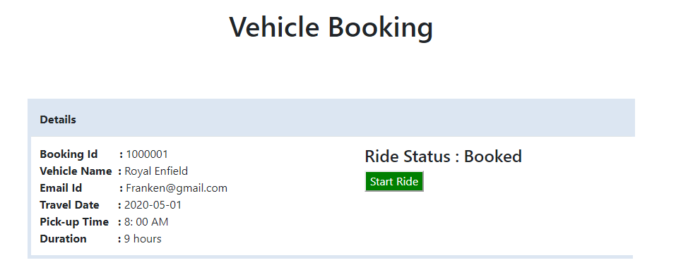
Figure – 14.1 Initial view, when is yet to start

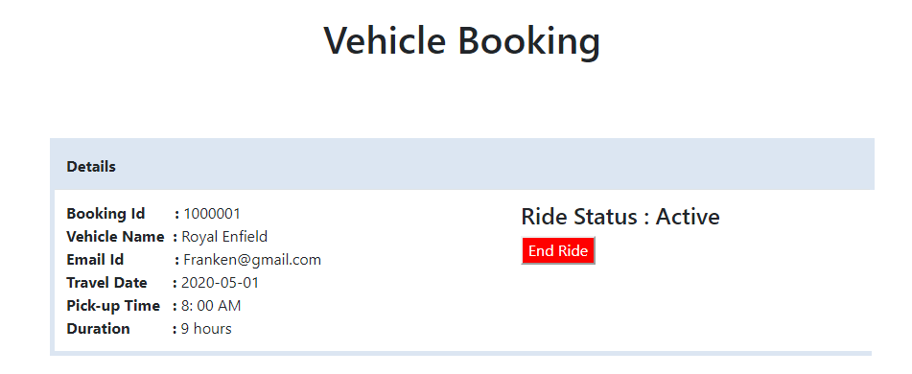
Figure – 14.2 Start/End Ride page with the ride as ‘Started’

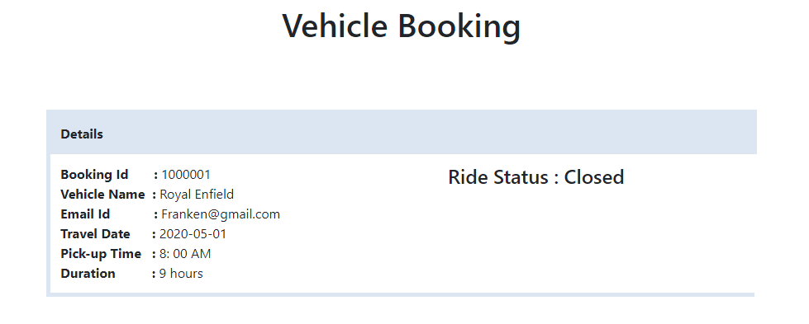
Figure – 14.3 Start/End Ride page with the ride as ‘Closed’

Add New Hotel
As an employee, I should be able to add new hotel details so that the customer can select accommodation during a package booking.

Validations/Acceptance Criteria
The employee should be able to enter the following details:
- New hotel Name
- Hotel rating with ratings between 2 to 5
- Price per room based on the type of room - Single, Double, Deluxe, Suite
- City name
- On successful validations, add the details in the database and navigate the employee to a page that displays all the hotel details
- In case of any exception, display appropriate message

Sample Screen

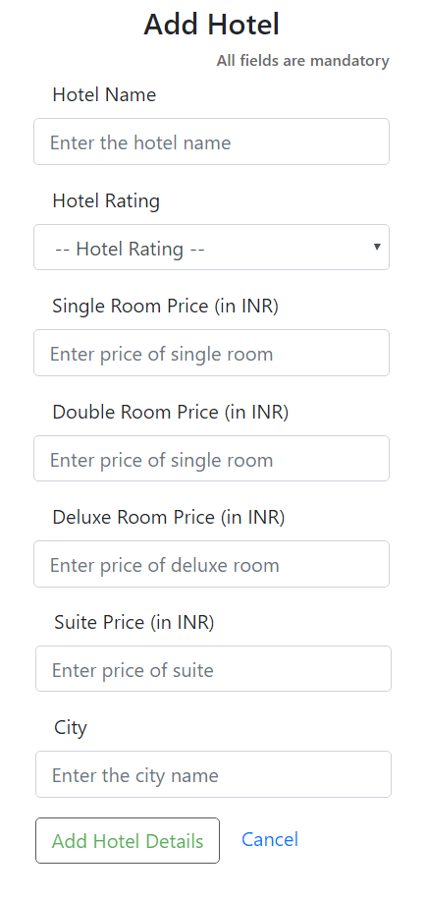
Figure – 15.1 Add Hotel page without data

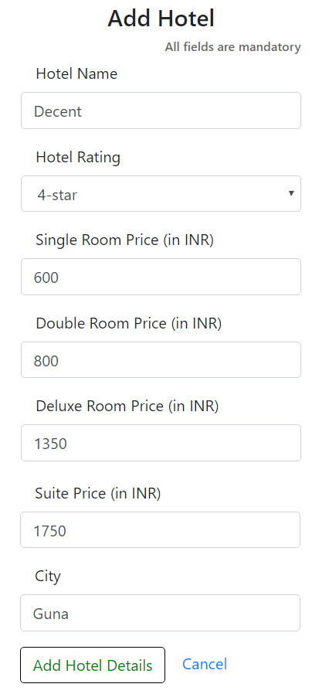
Figure – 15.2 Add Hotel page with data

Add New Vehicle
As an employee, I should be able to add new vehicle details so that the customer can select a vehicle to rent after reaching the destination city.

Validations/Acceptance Criteria
The employee should be able to enter the following details:
- Vehicle Name
- Vehicle Type. It can - Two-Wheeler, Four-Wheeler, Mini-Bus
- Rate per hour.
- Rate per kilometer
- On successful validations, add the details in the database and navigate the employee to a page that displays all the vehicle details
- In case of any exception, display appropriate message

Sample Screen

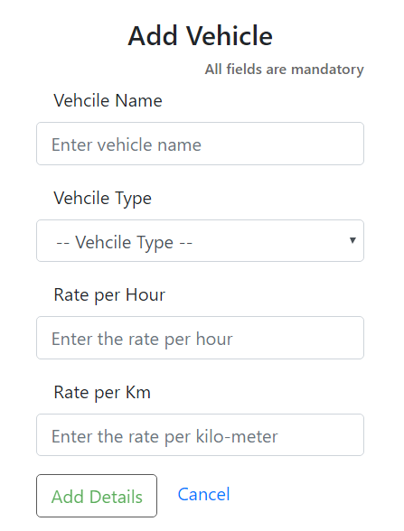
Figure – 16.1 Add Vehicle page without data

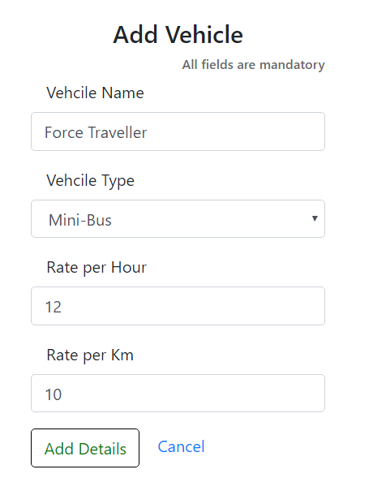
Figure – 16.2 Add Vehicle page with data

